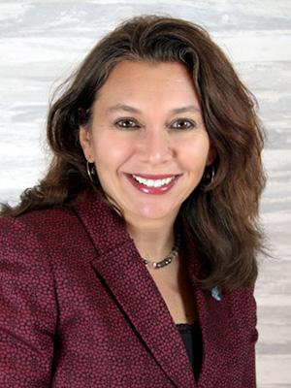
Amanda Seewald, M.Ed.
Amanda Seewald is the owner of MARACAS Language Programs and Learning Kaleidoscope Educational Consulting. She is the author of the MARACAS curriculum and Easy Reader series. Amanda is President-elect for the Joint National Committee for Language - National Council for Languages and International Studies (JNCL-NCLIS). She is the 2020 NECTFL Nelson H. Brooks Award winner for Outstanding Leadership in the Profession.
She is a past President of the Foreign Language Educators of New Jersey (FLENJ) and the N.J. State Representative for the National Network for Early Language Learning (NNELL). She has also served on the NECTFL board. Amanda also serves on the Board of Directors for the Pulsera Project. She is a speaker of Spanish, French, and Japanese.
Amanda has been teaching children, coaching educators, and developing curricula for over 20 years. Her expertise is in multilingual/multicultural curriculum and instruction, focused on early language learning as well as dual language immersion education. Amanda works with educators and schools across the country as well as in Europe to develop meaningful language programs founded in globally engaged curricula and strong interactive instruction. Amanda is a regular presenter at national, regional, and state conferences.
To learn more about Learning Kaleidoscope or MARACAS visit www.maracas123.com, on Facebook @learningkaleidoscope, or Twitter @maracas123.
KEYNOTE THEME
World Language Teachers: The Global Liaisons We Need – Amanda Seewald

As we continue to stretch the boundaries of education and empower our students to think global, world language educators have a unique and important role to play. What can you do to bring true global citizenship to your classroom, your school, and your community through language education? Join Amanda Seewald as she invites us to consider the possibilities and the tools that language educators have to make the global links our students need as we navigate the challenges along our paths.

