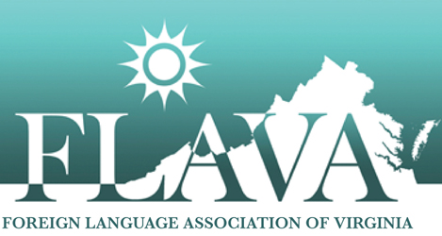

College/University Student Recognition

The Foreign Language Association of Virginia is pleased to announce a wonderful means of recognition for college and university level language students. FLAVA will honor up to five post-secondary language students who exemplify a keen interest in language study with free registration for its annual conference and free membership for one year. This year’s conference will be held October 4-6, 2018 at the DoubleTree by Hilton Williamsburg Hotel, and it is the expectation of the organization that the winners attend the Awards ceremony and luncheon on Friday, the 5th. The award may be contingent upon attendance at this function.
Each language department is encouraged to nominate students. The language professor simply writes a paragraph or two about the deserving student that describes his/her academic performance, personal qualities and character, and enthusiasm for language study.
Send the recommendation letter along with contact information (for professor and student – e-mail addresses and phone numbers) to
Jennifer Thomas and Maria Lourdes De Panbehchi

awards@flavaweb.org

The deadline for recommendations for this recognition is May 1, 2018.

College/University Recognition
Evaluation Sheet
(For use by Selection Committee)

Name of Nominee ___________________________________________________
Evaluator _________________________________________________________

Using the scale below, evaluate the student’s contributions to foreign language education in the following categories.
0  No evidence provided | 1 | 2  Weak | 3 | 4 | 5  Average | 6 | 7 | 8  Strong | 9 | 10  Excellent

_____ 1. Impact of the nominee’s leadership and contributions to the study of the language at the
school, regional and national levels
_____ 2. Nominee’s service to the profession at the local, regional and national levels
_____ 3. Nominee’s academic record

_____ 4. Nominee’s personal qualities and character
_____ 5. Nominee’s genuine enthusiasm for language study

_______ TOTAL (50 points maximum)

